Business Requirements Document (BRD)
Project Title: CAT Automation
Version: 1.0
Date: 15th June 2026
Author(s): Gaurav Gosain
Status: Draft

1. Project Charter

1.1 Project Overview
Problem Statement: Hiring for customer facing roles including but not limited to BPO requires candidates to be screened for English proficiency. Conventionally, this process has been conducted through a manual proctored interview test wherein candidates have to answer questions as guided by the interviewer, and their responses are recorded for evaluations as per CEFR guidelines. With a rising number of candidate applications from various geographies; conducting human led interviews has been challenging from quality, consistency and efficiency standpoint.
Proposed Solution (High-Level): Create an AI powered tool to transform the candidate hiring process by using the latest Speech and Generative AI models. The candidates go through a curated test as generated from a question bank, and their responses are recorded with both audio and video. Trained AI models are then used to assign CEFR scores to each candidate – thereby making the process autonomous and scalable.
In Scope:
- All the functional requirements as described and agreed with business in Section 3 with established timelines and budget.
- Target geographies for pilot are India and Philippines
- Annual candidate screening capacity of ~ 40,000

1.2 Business Objectives
- Reduce time-to-hire by batched autonomous evaluation agents
- Improve recruiter efficiency with help of status tracking for all candidates
- Improve candidate experience with prompt hiring updates
- Reduce bias and error

1.3 Key Stakeholders & Sponsors
Arvind Ojha | VP Training | OG Adv Admin & Strategy
Jason Cohen| Director Training | OG Adv Admin & Strategy
Divya Arora | Director Training | OG Adv Admin & Strategy
Anina Tolosa | Assistant Director Training | OG Adv Admin & Strategy
Mahesh Gupta | Business Analyst Consultant | OG Adv Admin & Strategy
Daksh Peepat | Senior Director AI-ML | Optum AI

1.4 Technical & Delivery Team
Gaurav Gosain | AI-ML Engineering Lead
Responsibility: Architecture, development and technical project management

2. Business Case & Project Information

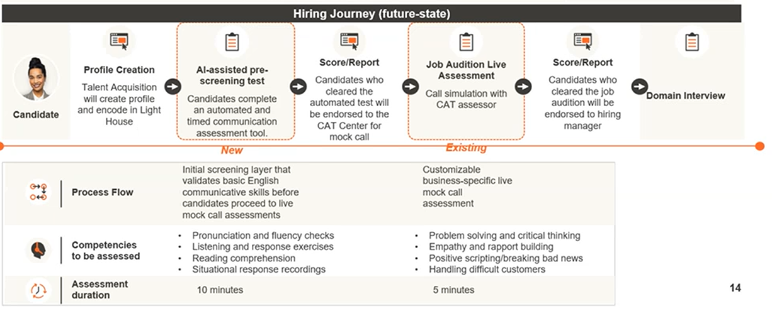

2.1 Current State (As-Is)
1. Candidate Profile Creation | Actor: Talent Acquisition Team
- Talent Acquisition (TA) identifies potential candidates from sourcing channels (job portals, referrals, etc.).
- TA creates a candidate profile in the LightHouse system (ATS).
- Candidate details captured include but not limited to:
  - Personal information
  - Resume / CV
  - Contact details
  - Role applied for

- Candidate profiles are validated and prepared for assessment stages.
2. Pre-Screening Test | Actor: Candidate + TA Recruiter / Interviewer
- Candidate receives an invitation link for an interview.
- Candidate joins the interview link on platforms – MS Teams etc.
- Candidate answers questions asked by the interviewer in a conversational manner.
- TA team evaluates the candidate based on basic communication competencies:
  - Pronunciation, fluency checks and grammar
  - Listening and response exercises
  - Lexicon and vocabulary
  - Situational response recordings

3. Job Audition – Live Assessment | Actor: Candidate + CAT Assessor
- Shortlisted candidates are scheduled for a live mock call assessment.
- Candidate joins a real-time session with a CAT (Communication Assessment Tool) assessor.
- Assessment is conducted as a call simulation (~5 minutes).
- Scenarios are business-specific and customizable.
- Assessor evaluates candidate performance during the live simulation.
- Evaluation is based on predefined competency frameworks.
- A structured score/report is generated.
- Feedback and evaluation notes are recorded in the system.
Skills evaluated:
- Problem solving and critical thinking
- Empathy and rapport building
- Communication clarity in structured conversations
- Handling difficult or sensitive situations
- Positive scripting / delivering complex messages

4. Final Shortlisting for Hiring Manager
Final shortlisted candidates are endorsed to the hiring manager for domain interviews.

2.2 Future State (To-Be)
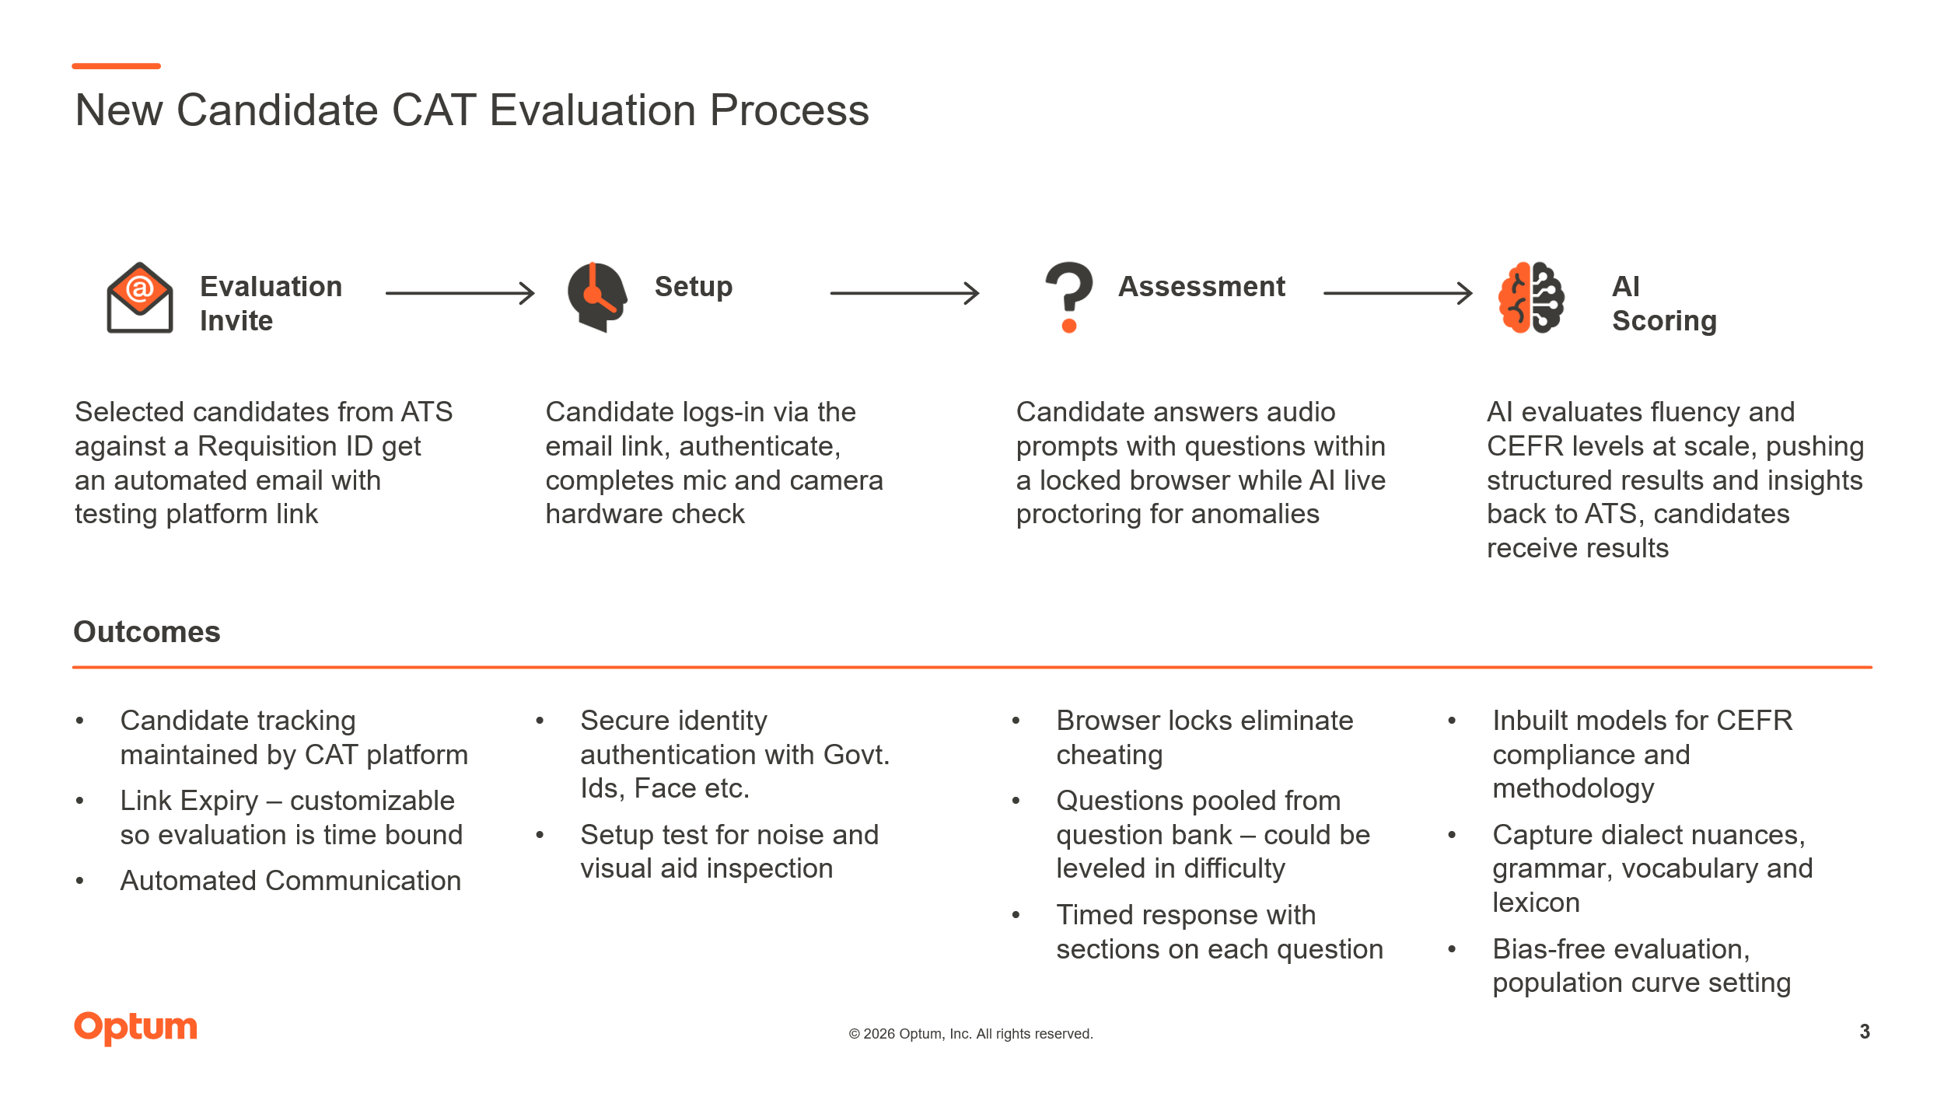
STEP 2. AI-Assisted Pre-Screening Test (New Layer Introduced)
Actor: Candidate + Automated Assessment System
- Candidate receives an invitation link for the automated communication assessment – link for assessment exposed to UHG External Users
- Candidate logs into the assessment platform.
- Candidate completes a timed AI-based pre-screening test (~10-20 minutes).
- The system evaluates basic communication competencies, including:
  - Pronunciation and fluency checks
  - Listening and response exercises
  - Reading comprehension
  - Situational response recordings
  - Lexicon and vocabulary

- Responses (audio + transcribed text + video) are recorded and analyzed automatically.
- Questions for the assessment are pre-fetched for a manageable question bank that can be edited and have Role Based Access Control.

STEP 3. Pre-Screening Score & Shortlisting
Actor: AI System + Talent Acquisition (New Layer Introduced)
- The AI system generates a score/report based on candidate performance.
- Candidates are categorized as per CEFR categorized scores
- Candidates who clear the AI screening are:
  - Endorsed for next stage
  - Shortlisted in ATS

- Candidate results are stored and made available for review.

2.3 Value Proposition

@Tolosa, Anina (add more as per proposition)
Quantitative Benefits
- Time saved per hire – efficiency improvements as AI models can run in batches
- Assessment volume reduction – geo-wise assessment volume
- Cost reduction – unit metrics for amount spent on each hire is reduced
- Throughput increase – scalability with a greater number of applicants and more geographies with varying dialects
Qualitative Benefits
- Better candidate experience – fully automated interview experience with prompt nudges and timelines for candidates to prepare and participate
- Standardized evaluations – evaluations tied to strict guidelines of CEFR with human in loop for continuous feedback and improvement
- Recruiter satisfaction – surety of hiring the best talent within a planned timeframe

2.4 Assumptions & Constraints
- Availability of historical hiring data with CEFR scores
- Legal / regulatory constraints related to PIIs (GDPR, etc.)
- Model explainability requirements – BIAS and Hallucination removal
- Budget / infrastructure limitations – as planned for production deployment

2.5 Risks & Mitigations (Table 2.1)
Risk | Impact | Mitigation
Bias in training data | High | Bias audits, diverse datasets, Human in Loop
Model accuracy | Medium | Human review, phased rollout, data monitoring
Regulatory compliance | High | AIRB Legal review, audit logs

3. Functional Requirements – FRs (Table 3.1)

FR Index | FR Category | FR Sub-Category | FR Description
FR – 1.1 | Core AI Capabilities | Candidate Evaluation | System shall score candidates against job requirements – align score according to CEFR guidelines
FR – 1.2 | Core AI Capabilities | Candidate Evaluation | Output confidence score and rationale
FR – 1.3 | Core AI Capabilities | Candidate Evaluation | Multi-language support – initial build for Indian and Philippines dialect’s
FR – 1.4 | Core AI Capabilities | Candidate Evaluation | AI generated voice for question recitation
FR – 2.1 | Core AI Capabilities | Explainability | System shall provide explanation for AI-driven recommendations
FR – 2.2 | Core AI Capabilities | Explainability | Feature-level contributions where feasible
FR – 3.1  (Optional) | Core AI Capabilities | Resume Parsing & Normalization | System shall extract structured data from resumes
FR – 3.2  (Optional) | Core AI Capabilities | Resume Parsing & Normalization | Supported formats: PDF, DOCX Fields: education, experience, skills, tenure
FR – 4.1 | Workflow & User Interaction | Recruiter Review Interface | View ranked candidates with scores and historical trends in an analytical dashboard hosted within the app
FR – 4.2 | Workflow & User Interaction | Recruiter Review Interface | Override AI recommendations – reviewer comments shown
FR – 4.3 | Workflow & User Interaction | Recruiter Review Interface | Feedback for model learning – via dynamic agentic instructions
FR – 5.1 | Workflow & User Interaction | Human-in-the-Loop Controls | Mandatory review before rejection or advancement
FR – 5.2 | Workflow & User Interaction | Human-in-the-Loop Controls | Escalation workflow for low-confidence predictions
FR Index | FR Category | FR Sub-Category | FR Description
FR – 6.1 | Audit & Logging | Decision Logging | Log AI recommendations
FR – 6.2 | Audit & Logging | Decision Logging | Log final human decisions
FR – 6.3 | Audit & Logging | Decision Logging | Retain logs for X years – as determined by retention policy
FR – 7.1  (In Prod) | Integrations | ATS Integration | Read/write candidate status
FR – 7.2  (In Prod) | Integrations | ATS Integration | Sync job requisitions
FR – 7.3  (In Prod) | Integrations | ATS Integration | Near real-time updates

4. Non-Functional Requirements

4.1 Performance & Scalability
- Process at least 20 resumes per hour
- Scoring latency ≤ 3 minutes per candidate
- Horizontal scalability for geographies

4.2 Security & Privacy
- PII encryption at rest and in transit
- Role-based access control
- Compliance with GDPR / local labor laws + AIRB review

4.3 Reliability & Availability
- Uptime ≥ 99.99%
- Graceful degradation if AI services fail – fall back logic and resolution plan
- Manual fallback workflows

4.4 Model Governance
- Versioned models – version control and deployment history
- Retraining cadence – aimed at least quarterly after stable Go-Live performance
- Drift detection and alerts

4.5 Usability & Adoption
- Minimal recruiter training required
- Clear AI confidence indicators
- Non-technical explanations

5. Success Metrics & KPIs

5.1 Business Metrics
- CAT Interview human time reduction by at least 75%
- Cost per hire reduction by at least @Tolosa, Anina
- Recruiter productivity (hires per recruiter) @Tolosa, Anina

5.2 AI/Model Metrics
- Precision / Recall / F1 greater than minimum threshold of 90%
- Hallucination Rate < 1%
- Override rate by recruiters < 25%

5.3 Adoption Metrics
- % recruiters actively using system @Tolosa, Anina
- % decisions influenced by AI recommendations (optional)

6. Resource Requirements

Human Capital
Role | Effort (Person-Months as calculated by FTEs x Time)
AI/ML Engineers | 3
Data Engineers | 0
Backend Engineers | 3
Product / UX | 3
QA | 0
Infrastructure
Details - Build Architecture Costs.xlsx
Total Monthly Cost ($) | 5,291
Cost per Case ($) | 1.60
Fixed Monthly Compute Cost ($) | 2736

7. High-Level Timeline & Milestones
Phase | Duration | Key Deliverables
Discovery & Data Audit | 3 weeks | Data readiness report
Design | 1 week | Architecture, model approach
Build | 5-6 weeks | MVP
Pilot | 2-3 weeks | Metrics validation
Rollout | TBD | Production launch

8. Approval & Sign-off
Name | Role | Signature | Date

